DATE: 01.02.2019
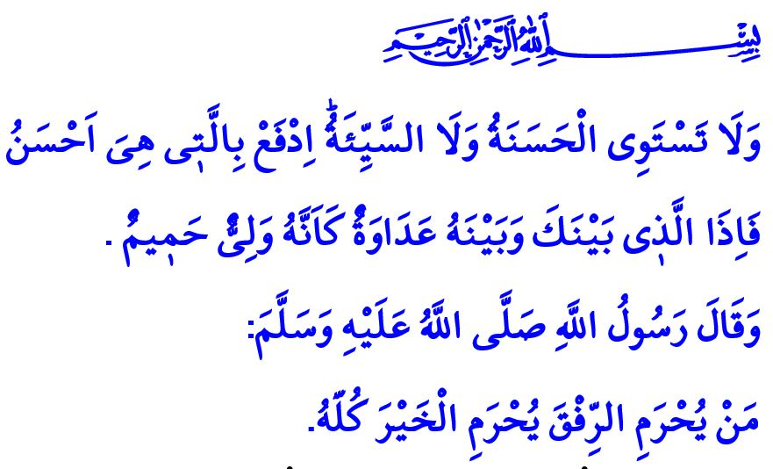RIFQ (GENTLENESS): ALLAH LOVES GRACIOUSNESS IN ALL AFFAIRS
Honorable Muslims!
The Almighty Allah states in the verse that I have recited, “And not equal are the good deed and the bad. Repel [evil] by that [deed] which is better; and thereupon the one whom between you and him is enmity [will become] as though he was a devoted friend.”
The Prophet Muhammad (saw) stated in the hadith that I have read, “He who is deprived of gentleness is deprived of good.”
Dear Believers!
Faith, worship, and good morality make the basis of Islam. Gentleness is one of the moral virtues that enables human to have higher value in presence of Allah and among the society. Being gentle means having a smiling face, a sweet tongue, and being humble. It means being someone who gets along well with others, who does not behave rudely and harshly, or break hearts. It means not falling for anger that darkens the mind and results in frustration, and being patient and calm.
Honorable Muslims!
Allah loves us to act in all our affairs with gentleness. He commands all believers to be forgiving and tolerant, as expressed in the verse, “Take what is given freely, enjoin what is good, and turn away from the ignorant.” In another verse, He counts “restraining anger and pardoning people” among the characteristics of people who have fear of Him and have the good news of forgiveness and paradise by Him.
Dear Believers!
The Messenger of Allah (saw) is the finest example for us to have kind behaviors. He treated kindly and compassionately not only people, but also all that exists. He always sought to facilitate all his affairs, and avoided causing any difficulty and hurting the people around him. Instead of punishing those who made mistakes, he opted to be forgiving. He advised not being oppressive and overwhelming, but rather any constructive behavior that fostered love and respect. Thanks to such virtues bestowed upon him by Allah, Muslims held together around him.
In this respect, the Almighty Allah states in the Holy Qur’an, “So by mercy from Allah, [O Muhammad], you were lenient with them. And if you had been rude [in speech] and harsh in heart, they would have disbanded from about you. So, pardon them and ask forgiveness for them and consult them in the matter…”
Honorable Muslims!
Believers who take the Prophet Muhammad’s morality as an example for themselves conduct all their relations with gentleness. Such believers do not avoid being compassionate even for the smallest living beings. With their austerity and elegance, as well as polite and considerate manners, they represent the noble values and the high morals of Islam. They refrain from any kind of extremism, rudeness, and violence. In this respect, the Prophet Muhammad said, “Believers do not insult the honor of others, utter curses, go to extremes, or nor do they foul”
Dear Believers!
Today, at a time when neglect of responsibility and values of being human is increasing, and violence is threatening humanity regardless of religion, language, ethnicity or geography, we should know that any attempt fueling violence has nothing moral, humane, or Islamic in it. We need to refrain from committing any act that damages human honor and grace; approach and treat our parents, spouses, children, relatives, and neighbors with gentleness, compassion, and in a friendly manner; be forgiving even when we are right, and be patient even when we are angry. In this respect, the Prophet Muhammad (saw) said, “The strong-man is not one who wrestles well, but the one who controls himself when he is in a fit of rage.” We should also know, however, that standing up rightfully against any attack targeting our national and religional values is a noble sign of moral excitement, religious sensitivity, piety, and loyalty to homeland.
Honorable Muslims!
Who has rifq has compassion for others, and who has compassion for others has Allah’s mercy. Who abandons rifq heads to violence and violence results in frustration on the Day of Judgment. Then, we should not let anger seize our mind and conscience, nor should we let impatience cast a shadow over our eternal salvation. We should always bear in mind the following saying of the Prophet Muhammad (saw), “Allah is gentle, likes gentleness, and gives for gentleness what he does not give for harshness.”

Fussilat, 41/34.
Abu Dawud, Adab, 11.
Bukhari, Adab, 35.
A’raf, 7/199.
Al-i Imran, 3/134.
Al-i Imran, 3/159.
Tirmidhi, Birr, 48.
Muslim, Birr, 107.
Muslim, Birr, 77; Abu Dawud, Adab, 11. General Directorate of Religious Services

